Meeting minutes of the Corner Canyon Hight School Community Council
Meeting held February 1, 2024. 5PM in the administrative conference room.

Attendees:
Jake Meyers
Andrea Lutz
Elizabeth Rooklidge
Misty Jolley
Cherie Zimmerman
Kevin Peterson
Miranda Jones
Christa Reid
Dina Kohler
Jana White
Angela Oldroyd

Not in Attendance:
Lindsey Parry
Nancy Nichols

Excused:
Kathy Hilton

Zooming in the meeting:
Dina Kohler

Not in Attendance:
Kevin Peterson
Jeff Colemere

Visitors:
Case Hamilton
Taylor Wallstead

***********************

Welcome: Christa Reid

Approval of meeting minutes.
95.5% page four typo corrected.

Motion to approve minutes:
Jana White

Second:
Angela Oldroyd

Elizabeth Rooklidge.
Counseling corner. Looking for students to be removed from Crew because they are progressing well or students who aren’t utilizing the program. Added new crew students for the new semester. Making sure students are vetted. Always approve new students for the new semester.

Feb 13 new student lunch. Activity to help new students feel welcome. Last lunch was in September.

Arena Scheduling is finished. They are required to stay in the one-year class. It impacts numbers when students try to unenroll from these. Trying to make students more mindful of their chosen classes. And watch graduation requirements. Can see in skyward the students’ progress to make sure they are good for grad requirements. Parents can also watch this. Freshman sometimes take out important classes…so trying to teach them to be mindful. Another layer of accountability.

Charger Fair held last night 1/31/2024. Incoming 2024-25 students (9th graders) are invited. Fun portion was a fair in the commons. Students were working hard helping new students know about clubs etc. Faculty also stayed to help. Successful Fair. Ben Poulson headed the fair. Good time for students and parents to ask questions.

Virtual course request survey done today. Encouraged them to be mindful again. Course request period is open from 2/1-2/114. Counselors go to DPMS next week to visit with students and help them with course requests for next year. This course request process is important to facilitate classes for the following year.

TSSP and LAND Trust
Misty Jolley (the following are the notes/data covered)

Below is disaggregated data requested from January SCC meeting of number of F’s that were awarded in both the 2022-23 and 2023-24 school year.
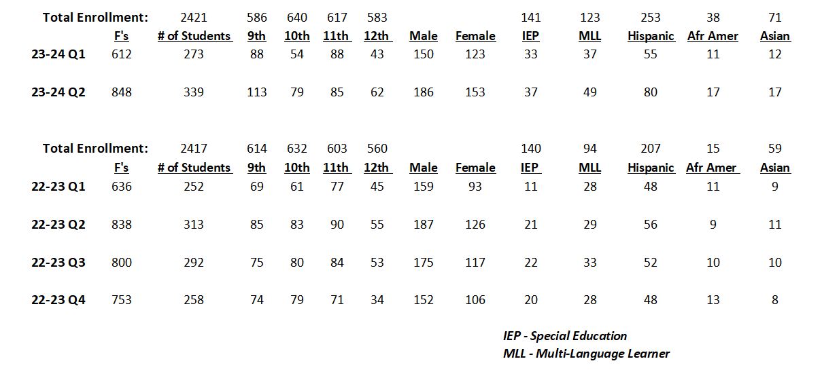

Proposed goal:
Corner Canyon High School aims to implement interventions to decrease the number of F grades awarded during a single school year. School data shows an average of 750 F’s were distributed in the 2022-2023 school year and 730 F’s in the 2023-2024 school year. Specifically, the goal is to reduce the f grades by 7% by May 2025.
A proposed list of action items:
- Create two periods of English Language Development classes for MLL students as an intervention. - $20,000 from Landtrust.
- Provide two periods of reading classes as an intervention for struggling readers, MLL students and SPED students as an intervention. - $20,000 from Landtrust.
- Hire a 0.5 SPED teacher. - $40,000 from Landtrust
- Purchase instructional technology for students to access digital content. - $20,000 from Landtrust, $10,000 from TSSP.
- Provide opportunities for staff to attend professional development conferences to enhance their knowledge of proven instructional strategies and how to provide engagement strategies, rigor, and feedback for students. - $13,500 from TSSP.
- Hire an ELD 28-hour instructional aide to work in ELD class and work with MLL students in their core classes and who can translate Spanish. - $18,000 from Landtrust.
- Pay multiple teachers to take a 7th period to lower class sizes in core subjects. - $60,000 from TSSP.
- PBIS incentives. Supplies for PBIS incentives not to exceed $2 per student. -$2,500 from Landtrust
- Hire two 28-hour STEM instructional aides (one for the math department and one for the science department). - $28,000 from TSSP.
- Provide funding for an after-school Math/Science enrichment program and funding for two instructional support aides for both math and science. - $5,500 from Landtrust
- Hire two tutors to work in the after-school math enrichment program. -$3,000 from Landtrust.
- Provide four periods of math lab to ensure those students who struggle the most with math are able to have math every day (double-blocked). This will consist of two Secondary I, two Secondary II. - $40,000 from Landtrust
- Hire additional teachers to lower class sizes in core subjects (math, science, ELA, social studies). - $140,000 from Landtrust.
- Help support the development of CCHS robotics program in an effort to provide STEM opportunities for students. - $5,000 from TSSP
- STEM based instructional materials and books to support students. - $10,000 from Landtrust.
- STEM based instructional software to support students. - $5,000 from TSSP.
- PBIS incentives not to exceed $2 per student. $2,500 from Landtrust.
- Provide the funding for of the salary for an additional school counselor. This extra counselor will provide additional student services and connections with students. - $70,000
- Pay the salary (one FTE) for the teacher who runs our at-risk student program (CREW), which is a Tier II intervention. - $70,000
- Provide the funding for one additional hall monitor. -$50,000
- Help fund various instructional aides to provide support for not only teachers, but students.
- (CREW aide 17 hr., MTSS behavior aide 28 hr., and a 504 aide/testing coordinator aide 35 hr). $32,000
- Provide team building and wellness community night. --$5,000
- Provide school-wide PD on PBIS and the instructional value of teacher-student connections. -$0
- Utilizing our instructional support coach to provide school-wide PD on engagement strategies, rigor, feedback, student motivation, as well as providing PLC support - $0
- Utilizing our instructional support coach to provide PD on ways that staff can use digital literacy in their classrooms. - $0

*******

COMMENTS ON PROPOSED GOALS
Nancy Nichols noticed that it goes up every quarter.

Christa Reid asked if affected English or math more. Misty clarified that its core classes. She said we need to come up with a goal to help mitigate.

Dina Kohler commented on mindset. Reminded everyone that we have the highest grad rate in the state. We pay attention now to make sure we are on top of it for graduation. We target this early. Reminder that we have high achieving students generally.

Misty Jolley. Said we are the only high school with THREE TSSP goals. Wants to condense that into ONE goal. Let’s focus on one goal if everyone is okay with that. (see goals proposed above)

She asked council if there is something different they would want in terms of goals.

Nancy Nichols commented that we need to have a standard in the school for turning in missing assignments. Vs. different for each teacher. (Make this an action item?)

Nancy commented again that middle school has 82% for math and it drops dramatically when they come to HS.

Jake Meyers asked if we have filled all positions we have for stem classes? Misty: yes. Do we have room to hire more? Misty said we currently employ 91 teachers (total)…on average our math classes are the smallest because of the funding provided by TSSP. Jake-Do we have ways to limit kids on “teacher shopping” and reducing class sizes. Misty: need to change the mindset for teachers on how they teach so the classes are approachable for ALL students. They are always looking for best practices and implementing them here at CCHS.

Jana White: When CCHS switched to AB schedule, it made the class sizes bigger by 2 students on average. Limited by space on AB block schedule. It’s why we are where we are.

Mr. Anderson: Some of the more targeted groups that we are worried about, we are trying to look at intervention classes for those kids. IEP and Multilingual students are failing at a higher rate. Trying to allocate funds to more specialized classes (Crew) for failing student group.

Jake Meyers: Questioned if we are putting too many monies there and ignoring higher level kids.
Misty Jolley commented that the middle students need to be pushed more.
Mr. Anderson commented: getting F kids to D’s.

Jake M commented we don’t know how much high achieving kids would benefit with extra resources…we don’t know because we never put money there.

Dina Kohler. We are bound by TSI to spend on a minimal number of resources focused on keeping grad rate high.

Andrea Lutz commented about a program recommended by another teacher that helps kids with reading. She will follow-up on what that program is.

COMMENTS ON PROPOSED LIST OF ACTION ITEMS:
Misty asked council to read through list of action items and email thoughts after reading. Next meeting, we will bring thoughts together next meeting.
Jana White said commented…can we hire teachers for science, stem, math, social studies. We have one MLL for English now.
Mr. Anderson: we are working to bring in another (Julianna Mayer funded by TSSP now) person. Proposed to have space for a 17-hour person too. We need to work on more ELS endorsed teachers in our program…they are hard to find.
Jana W: Maybe we have small classes in MLL in every department in 7th period classes. Teachers can’t support everyone in the class well when trying to divide.
Subject specific crew class essentially.
Jake Meyers asked if there was a baseline on ML students to see when they go to population of students. Misty Jolley said yes. WIDA test? Taken in Feb/March. Score of 1-5 on English proficiency.

There aren’t accommodations for non-English speakers. Reason for proposing a small crew type class using the resources for all of the ML kids in the one class.
Andrea Lutz asked about the hire. Are we having a problem with pay?
Mr. Anderson: We have a hard time hiring for 17 and 24-hour jobs. Doesn’t pay competitively.

District assigns the pay. Facility can’t change pay rates. At board level. More doable to pay a teacher extra to do some of this. Julianna is vital to what they are trying to do with translation/interpretation services.
Jana W proposing a set schedule for someone (even with AB schedule) to help find a person to fill that role.

Jake M. Proposed making every teacher have second language software to learn languages available.
Misty J said maybe we allocate money towards this. Give teachers a stipend when they reach levels with his to incentivize them to continue and become more proficient.

Christa Reid: Create a sub-committee for the writing of goals and allocation of money. This group will present to the entire council in March.

Sub-committee:
Andrea Lutz
Jake Meyers
Misty Jolley
Christa Reid
Miranda Jones
Taylor Anderson

School Info-Misty Jolley

Review of current sports/academic happenings. Including mock trial competing next weekend. Monster concert included DPMS kids as well. Because of Land trust and TSSP money, we’ve been able to send teachers to lots of continuing education.

Spoke about issue with attendance. Trying to teach teachers the important of attendance. Each Monday attendance secretary gives list of high non-attending students. Counselors meet with those students and try to intervene. Office staff also make connections with students and some students are assigned to office staff for daily or weekly accountability. Trying to build connections with kids to help facilitate attendance and make it matter. The hope is to make them feel that they matter.

We have had a donation from a community member which was allocated for a food pantry for needing students at the school. Goes through canyons education district. Parents can donate to that.

Fieldhouse got approved. Turf for baseball infield. Outfield for soccer. Turf for soccer fields. Additional classes in fieldhouse. Breaking ground in June. 15-18 months to complete. Completion in 2025. T Anderson and M Jolly will be following this. Fields should be done more quickly. They will be completed over summer 2024. Placement of fieldhouse is still in discussion. (affects soccer fields)

Academic stats.
Q2 2405 students earned credit. 973 were on high honor roll. 315 on honor roll
32 seniors earned 4.0 all 4 years.

Ms. Banks has been working with kids about seal of biliteracy. Some of the Hispanic kids didn’t get it, but they were informed. It also went out on Parent Square more than once. The district also sent info on this.

Getting kids out of TSI status by having kids take AP English and other things.

Andrea Lutz: talked about cell phone issue. Teacher at Jordan had to replace a phone when they had taken it from a student (it got stolen). We will consider this liability when we revisit this after TSSP and Land Trust discussions.

Cherie Zimmerman: Kids are driving dangerously by tennis courts. Stop sign is missing so kids aren’t stopping. M Jolley said maybe police presence. Also need to replace stop sign. She will relay to safety committee to get some solve on this.

Christa Reid complemented on teachers writing handwritten notes to kids. Super cool.
T Anderson commented: it’s been a big focus. About half of the students have received cards from teachers this year.

Next month, meeting at 4pm on 3/7/2024 due to boys’ state basketball games.

Motion to adjourn:
Jana White

Second:
Jake Meyers

Meeting ended 6:10 pm

