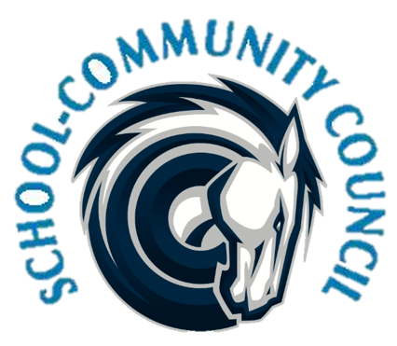
School Community Council Agenda
October 5 (Thursday) - 5:00 PM at Administrative Conference Room
- Welcome and Introductions- Jennifer Kalm

- SCC Elections- Jennifer Kalm

- Review and Approval of May2023 minutes-

- Counseling Corner- Elizabeth Rooklidge

- Teacher and Student Success Plan (TSSP) and School LAND Trust Program- Misty Jolley

  - Final Report from 2022-2023

- School Safety Plan- Dave Barrett and Officer Smith

- Digital Citizenship Plan- Maria Jones

- Set SCC dates for this year-

- Attendance Requirement, Compliance Items, Review Bylaws-

- Charger Time-

- School Info- Dina Kohler

- Other Items-

- Adjourn

Excused:

Next Meeting: November 2, 2023, at 5pm
Proposed 2023-2024 SCC Dates:
November 2- 5pm
December- No meeting
January 4- 5pm
February 1- 4pm- Due to Charger Fair
March 7- 4pm- Due to Boys State Basketball Game
April 11- 5pm- One week later due to Spring Break
May 2- 5pm

