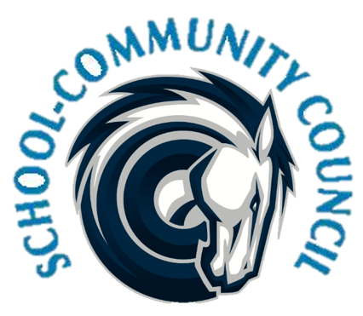
School Community Council Agenda
May 4, 2023 (Thursday) - 5:00 PM at Administrative Conference Room
1. Welcome- Jennifer Kalm

2. Review and Approval of April 2023 minutes- Jennifer Kalm/Kathy Hilton

3. Counseling Corner- Elizabeth Rooklidge

4. Teacher and Student Success Plan (TSSP) and School LAND Trust Program, - Steve Bailey

5. School Info – Darrell Jensen

6, SCC Elections for Next Year

7. Other Items

8. Adjorn

Excused: Stephanie Fowler, Cherie Zimmerman

Next Meeting: Thursday, September 7, 2023 - 5:00 p.m.

