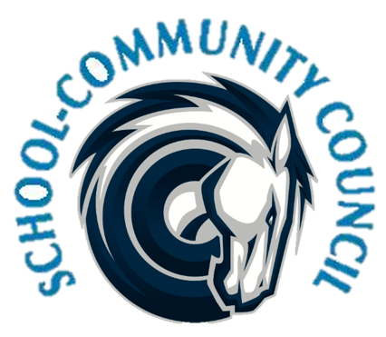
School Community Council Agenda
Adpril 13, 2023 (Thursday) - 5:00 PM at Administrative Conference Room
- Welcome- Jennifer Kalm

- Review and Approval of March 2023 minutes- Jennifer Kalm/Kathy Hilton

- Counseling Corner- Elizabeth Rooklidge

- School Safety- Officer Smith

- Teacher and Student Success Plan (TSSP) and School LAND Trust Program- Steve Baily

- Signature Page

- School Info- Darrell Jensen

- Adjourn –

Excused:

Next Meeting: Thursday, May 4, 2023 -- 5:00 p.m.

