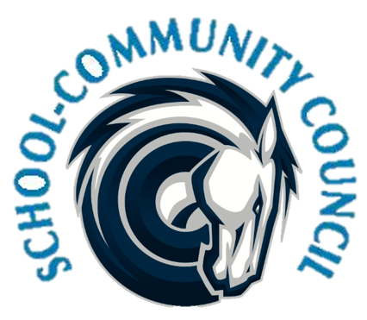
3
School Community Council Agenda
February 2,2023 (Thursday) - 4:00 PM at Administrative Conference Room
- Welcome- Jennifer Kalm

- Review and Approval of January 2023 minutes- Jennifer Kalm/Kathy Hilton

- Counseling Corner- Elizabeth Rooklidge

- Teacher and Student Success Plan (TSSP) and School LAND Trust Program, - Steve Bailey
  - Date for sub committee to meet

- School Info – Darrell Jensen

- Other Items -

- Adjourn –

Excused:

Next Meeting: Thursday,March 2nd, 2023 -- 5:00 p.m.

