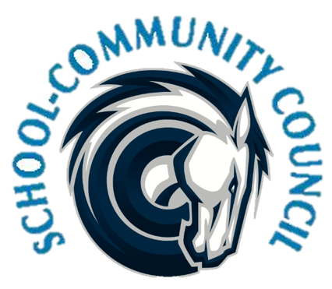
School Community Council Agenda
January 5, 2023 (Thursday) - 5:00 PM at Administrative Conference Room
- Welcome- Jennifer Kalm

- Review and Approval of November 2022 minutes- Jennifer Kalm/Kathy Hilton

- Conseling Corner- Elizabeth Rooklidge

- Teacher and Student Success Plan (TSSP) and School LAND Trust Program, - Steve bailey

  - Create sub committee

- School Info – Darrell Jensen

- Charger Fair – Ben Poulsen

- Other Items-

- Adjourn –

Excused:

Next Meeting: Thursday, February 2nd, 2022 -- 4:00 p.m.

