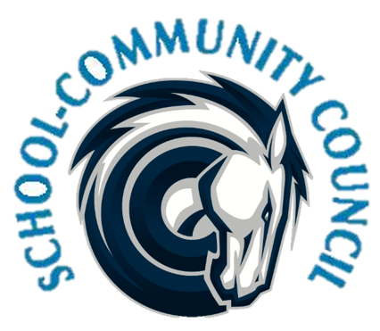
School Community Council Agenda
October 6, 2022 (Thursday) - 5:00 PM at Administrative Conference Room
- Welcome

- Review and Approval of September 2022 minutes- Jennifer Kalm/Kathy Hilton

- Digital Citizenship- Maria Jones

- Conseling Corner- Elizabeth Rooklidge

- Teacher and Student Success Plan (TSSP) and School LAND Trust Program, - Steve Bailey
  - Goals and Budget

- Attendance Requirements, Compliance Items- Jennifer Kalm

- Review of Bylaws- Jennifer Kalm

- Time Change for February SCC meeting- Jennifer

- School Info – Darrell Jensen

- Other Items -

- Adjourn –

Excused: Robin Jensen

Next Meeting: Thursday, November 3, 2022-- 5:00 p.m.

Meeting dates for 2022/2023 CCHS SCC
January 5th 5pm
February 2nd *4pm
March 2nd 5pm
April 13th 5pm
May 4th 5pm

